REGULAR MEETING OF THE BOARD OF TRUSTEES
OF PIERCE COLLEGE

October 11, 2017
Pierce College Fort Steilacoom
1:00 p.m.
NOTE: Study Session 12:00
AGENDA

1. Call to Order/ Establishment of a Quorum.

2. Safety Announcement

3. Flag Salute

4. General Matters.
A. Changes or Additions to the Agenda.
- Approval of Minutes for September 13, 2017
- Change of Officers

5. Public Comment

6. College Input and Reports
- Associated Students of Pierce College Fort Steilacoom (ASPCFS) President.
Elijah Ellis
- Associated Students of Pierce College Puyallup (ASPCP) President.
Garrett Brown
- Pierce College Federation of Teachers (PCFT) President.
Beth Norman
- Washington Public Employees Association (WPEA) Chief Job Steward
Cindy Bassage

7. Setting Direction/Vision
A. Chancellor Report

8. Board Action
A. Board Action 2017-44 Pierce College Fort Steilacoom Services & Activities Fund Balance Expenditure

9. Institutional Effectiveness Monitoring Report
A. Pierce College Fall 2017 Enrollment Analysis TAB 1

10. Innovation and Student Success
A. Pierce College Outreach and Enrollment Strategies

11. Board Business
- Board Chair Report
- Activities Calendar

12. Executive Session.
Under RCW 42.30.110, an executive session may be held for the purpose of receiving and evaluating complaints against or reviewing the qualifications of an applicant for public employment or reviewing the performance of a public employee; consulting with legal counsel regarding agency enforcement actions or actual or potential agency litigation; considering the sale or acquisition of real estate; reviewing professional negotiations; and/or reviewing recommendations relative to the award or denial of tenure or renewal or non-renewal of faculty contracts.

Date of Next Meeting. November 8, 2017 Pierce College Puyallup

13. Adjournment

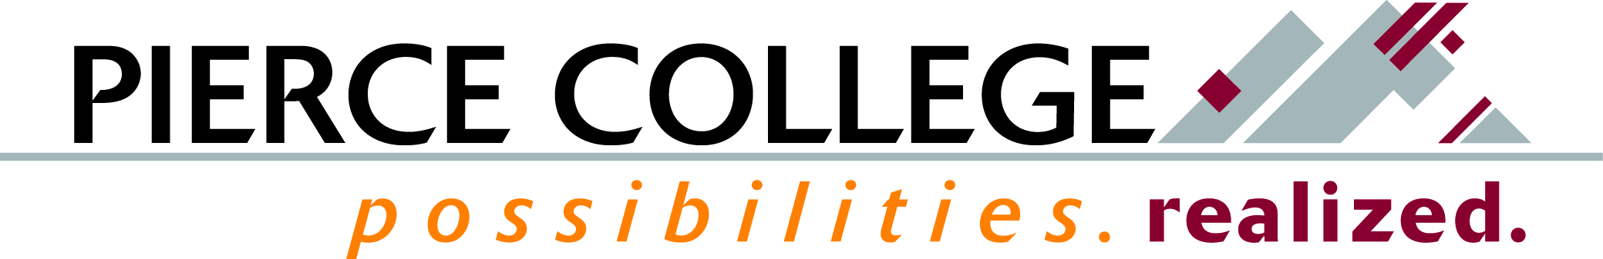

Tab 1

Mission Fulfillment Monitoring Report
SEM: Fall 2017 Enrollment Analysis

Brief Description
We will take a look at key enrollment figures for Fall 2017, and discuss them using a Strategic Enrollment Management (SEM) lens.

How This Reflects Mission, Core Themes or the Board’s Annual Goals
This report focuses on the core theme of Access, specifically on the Enrollment objective.

Background Information and Analysis
The rationale for Pierce’s Access core theme is: The community Pierce College serves will have access to comprehensive educational offerings and support services. Enrollment is the objective this report focuses on—specifically, the college’s metrics relating to the enrollment and retention of students. Please note that data for this report will not be available until after the 10th day (census) of the quarter. Therefore, this background information reflects metrics to be discussed, rather than specific measures. These will include:
- Fall enrollment trends
- Enrollment demographics
- Enrollment by student intent
- Fall-to-fall retention update

Potential Questions
- What can our enrollment data tell us about access equity gaps?
- Where are potential areas for improvement to target through SEM?

Prepared by: Erik Gimness, Director for Institutional Research, Analytics, and Effectiveness

Tab 2

Innovation Report
Outreach for Enrollment: Strategies

Brief Description
Outreach is a cross-institution activity. We will be highlighting a few current and upcoming outreach activities, including on-site middle school and high school outreach, use of social media for outreach, and how our grant-supported programs like TRiO and ASPIRE have enhanced our ability to advance equity, diversity, and inclusion through focused, community-based outreach activities.

How This Reflects Mission, Core Themes or the Board’s Annual Goals
This report focuses on the core theme of Access (through increased enrollment and opportunities in higher education), Contribution to Community (by serving educationally underserved communities) , and Equity, Diversity, and Inclusion (by building relationships with and opportunities for traditionally underserved populations to engage and enrich the Pierce College community).

Background Information and Analysis
Outreach takes place across the college and is conducted by staff and faculty in many formal and informal venues. As traditional outreach activities become less effective, we are working to hone our formal outreach programs to become more strategic and more responsive to the digital age. Simultaneously, we recognize that outreach is more relational than ever, requiring authentic community connections, support, and partnerships.

We will briefly highlight:
- Current as well as innovative outreach efforts conducted in conjunction with school districts and partner colleges
- Pierce Connect, our email-based, lead-driven outreach tool
- Social media for focused outreach
- Unique approaches that more fully consider and authentically respond to cultural needs
- Strategies to increase educational and economic attainment, particularly with regard to non-cognitive barriers

Guest speakers include Ruthie Schindler, Jessica Freier, Dawn Reed, Kiana Fuega, and students who participate in or have come to us through our outreach efforts.

Potential Questions
- How might we be more strategic in our Outreach program? What else should we be doing, and what might we stop doing?
- How might we bring the grant funded outreach programs to scale?

