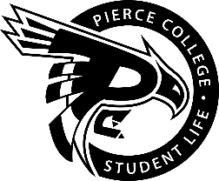
Pierce College Fort Steilacoom
Student Government Meeting Agenda

Location: Student Life Lobby

Date: Thursday, September 27th, 2018

Time: 1:00 p.m. – 2:00 p.m.

Agenda Details:
- Call to Order:
- Pledge of Allegiance:
- Roll Call:
- Establishment of Quorum:
- Changes to the Agenda
- Reports:
- Old Business
- New Business
- Action Item 1819-001: To ratify Eli Ellis as Special Events Coordinator for the 2018-2019 Academic Year.
- Action Item 1819-002: To ratify Yajahira Dominguez as Entertainment and Recreational Coordinator for the 2018-2019 Academic Year.
- Action Item 1819-003: To ratify Chris Horn as Communications Coordinator for the 2018-2019 Academic Year.
- Action Item 1819-004: To ratify Kim Nucum as Promotions Coordinator for the 2018-2019 Academic Year.
- Action Item 1819-005: To ratify Aiden Helt as Issues and Awareness Coordinator for the 2018-2019 Academic Year.
- Action Item 1819-006: To ratify Emma Gallagher-Burkholder as Outreach Coordinator for the 2018-2019 Academic Year.

- Open Forum
- Announcements
- * October 11th 2018 @ 1:00 pm in the Student Life Lobby
- Adjournment

