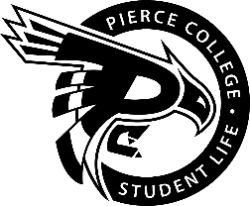
Pierce College Fort Steilacoom
Student Government Meeting Agenda

Location: Student Life Lobby

Date: Thursday, October 25th, 2018

Time: 1:00 p.m. – 2:00 p.m.

Agenda Details:
- Call to Order:
- Pledge of Allegiance:
- Roll Call:
- Establishment of Quorum:
- Changes to the Agenda:
- Approval of Minutes:
- Reports:
- Old Business:
- New Business:
- Action Item 1819 – 009: To ratify K-Pop / Asian Culture Club as a club for the 2018-2019 Academic Year
- Action Item 1819 – 010: To ratify Queer Support Club as a club for the 2018-2019 Academic Year
- Action Item 1819 – 011: To ratify Connor Fredericks as a member of the Tenure Committee for the 2018-2019 Academic Year.
- Action Item 1819-012: To ratify Chloesciara Galiki as a member of the Tenure Committee for the 2018-2019 Academic Year.
- Action Item 1819 – 013: Ratify Jandlyn Perez as a member of the Tenure Committee for the 2018-2019 Academic Year.
- Open Forum:
- Announcements:
- Next meeting is November 8th 2018 @ 1:00 pm in the Fireside Lounge
- Adjournment:

