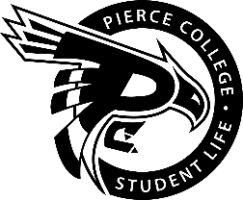
Pierce College Fort Steilacoom
General Assembly Agenda

Location: Student Life Lobby

Date: Thursday, December 6, 2018

Time: 1:00 p.m. – 2:00 p.m.

Agenda Details:
- Call to Order:
- Pledge of Allegiance:
- Roll Call:
- Establishment of Quorum:
- Changes to the Agenda:
- Approval of Minutes:
- Approval of the minutes from the November 29, 2018 Special Assembly.
- Announcements:
- Reports:
- Old Business:
- New Business:
- Action Item 1819 – 023: To approve funding for the Abode and Microsoft renewal quote from the Tech Fee contingency for the requested amount of $9955.15.

- Open Forum:
- Next meeting is January 18, 2019 @ 1:15 pm in the Student Life Lobby.
- Adjournment:

