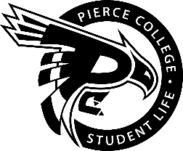
Pierce College Fort Steilacoom
General Assembly Agenda

Location: Fireside Lounge

Date: Thursday, November 6 ^{th}, 2018

Time: 1:00 p.m. – 2:00 p.m.

Agenda Details:
- Call to Order:
- Pledge of Allegiance:
- Roll Call:
- Establishment of Quorum:
- Changes to the Agenda:
- Approval of Minutes:
- Approval of the minutes from the October 25, 2018 General Assembly.
- Announcements:
- Reports:
- Old Business:
- New Business:
- Action Item 1819 – 016: To approve funding for the Student Veteran’s Organization’s Club for the Student Veterans Celebration Event for the proposed amount of 1080.1 from the Student Government Contingency Budget.
- Action Item 1819 – 019: To ratify K-Pop/Asian Culture Club as a club for the 2018-2019 Academic Year.

- Announcements
- Open Forum:
- Next meeting is November 8, 2018 @ 1:00 pm in the Student Life Lobby.
- Adjournment:

