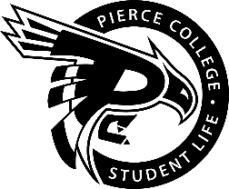
Pierce College Fort Steilacoom
General Assembly Agenda

Location: 3rd Floor Cascade Lobby

Date: Tuesday, November 8 ^{th}, 2018

Time: 1:00 p.m. – 2:00 p.m.

Agenda Details:
- Call to Order:
- Pledge of Allegiance:
- Roll Call:
- Establishment of Quorum:
- Changes to the Agenda:
- Approval of Minutes:
- Approval of the minutes from the November 6th, 2018 Special Assembly.
- Reports:
- Old Business:
- New Business:
- There is no new business to be reviewed at this time.
- Open Forum:
- Announcements:
- Next meeting is November29th 2018 @ 1:00 pm in the Student Life Lobby.
- Adjournment:

