REGULAR MEETING OF THE BOARD OF TRUSTEES
OF PIERCE COLLEGE

January 9, 2019
Pierce College Puyallup
1:00 p.m.
NOTE: Study Session 11:45
AGENDA
1. Call to Order/ Establishment of a Quorum.

2. Safety Announcement

3. Flag Salute

4. General Matters.
A. Changes or Additions to the Agenda.
- Approval of Minutes for November 8, 2017

5. Public Comment

6. College Input and Reports
A. Associated Students of Pierce College Puyallup (ASPCP) President.
Elyse Flury
- Associated Students of Pierce College Fort Steilacoom (ASPCFS) President.
Raymond Power
- Pierce College Federation of Teachers (PCFT) President.
Beth Norman
- Washington Public Employees Association (WPEA) Chief Job Steward
Cindy Bassage

7. Setting Direction/Vision
A. Chancellor Report

8. Board Action
A. Board Action 2019-01 Honoring President Denise Yochum

9. Institutional Assessment and Quality Assurance
A. Budget Planning Documents 2019

10. Institutional Effectiveness Monitoring Report Tab 2
A. Student Success through Online Learning: Trends, Insights, and Opportunities

11. Innovation and Student Success
A. Race and Inclusive Pedagogy: Implementation Strategies

12. Board Business
- Board Chair Report
- Activities Calendar

13. Executive Session.
Under RCW 42.30.110, an executive session may be held for the purpose of receiving and evaluating complaints against or reviewing the qualifications of an applicant for public employment or reviewing the performance of a public employee; consulting with legal counsel regarding agency enforcement actions or actual or potential agency litigation; considering the sale or acquisition of real estate; reviewing professional negotiations; and/or reviewing recommendations relative to the award or denial of tenure or renewal or non-renewal of faculty contracts.

Date of Next Meeting. February 6, 2019 Pierce College Fort Steilacoom

14. Adjournment
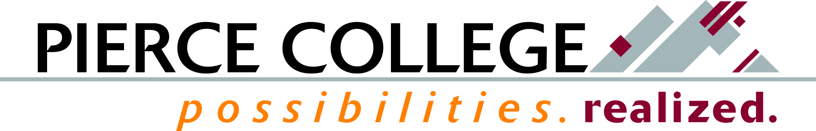

January 2019 Tab 2

Mission Fulfillment Monitoring Report
Student Success through Online Learning: Trends, Insights, and Opportunities

Brief Description
We will review 5 years of data on e-learning, looking at enrollment and course success.

How This Reflects Mission, Core Themes or the Board’s Annual Goals
E-Learning data presented here are related to both the enrollment objective and the course completion indicator.

Background Information and Analysis
Pierce has made good progress on e-learning both in terms of enrollment and course success rates over the last five years. Although the gap between grounded course success rates and online success rates continues to close, there have been ups and downs. Online course enrollment rates continue to climb, especially for the Running Start population.
During the ATD coaches’ visit in December, the college received feedback on opportunities to continue to work towards. One is continued investment into course design and faculty preparation. Next is enhanced engagement and delivery, which the college is already working towards through current use of the Quality Matters design process, and upcoming use of the WA Checklist for Course Design in order to improve delivery. Pierce was also advised to maintain its focus on improved orientation and retention processes for students in online courses.

Potential Questions
- What preparation does a student need prior to taking online courses?
- What are the life struggles that impact success in online course completion?
- Does mirroring face-to-face delivery structures support these life issues as they happen?

Prepared by: Erik Gimness, Director for Institutional Research, Analytics, and Effectiveness

