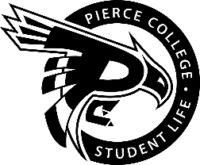
Pierce College Fort Steilacoom
General Assembly Agenda

Location: Student Life Lobby

Date: Friday, February 01, 2019

Time: 2:00 p.m. – 3:00 p.m.

Agenda Details:
- Call to Order:
- Pledge of Allegiance:
- Roll Call:
- Establishment of Quorum:
- Changes to the Agenda:
- Approval of Minutes:
- Approval of the minutes from the January 18, 2019 General Assembly.
- Reports:
- Old Business:
- New Business:
- Action Item 1819 – 031: To ratify Daniel Dino-Slofer to be a member of the Services & Activities / Tech Fee Budget Committee for the 2018-2019 Academic Year.

- Open Forum:

- Announcements:
- Emerging Leaders Academy / Multicultural Leadership Institute Intensive is February 7 from 9:00 A.M. to 5:00 P.M. in HEC 302.
- Snoqualmie Snow Day is February 8, 2019. Busses leave at 8:00 A.M.
- Cupid’s Casino is February 14, 2019 @ 11:00 A.M. – 2:00 P.M. in the Performance and Fireside Lounge.
- Cascade Blood Drive and Bone Marrow Registration is February 4 & 5 from 8:30 A.M. – 3 P.M. in the Outside Commons
- Adjournment:

