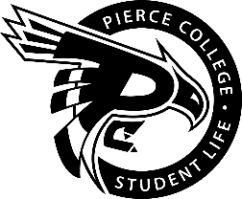
Pierce College Fort Steilacoom
General Assembly Agenda

Location: Student Life Lobby

Date: Friday, February 15, 2019

Time: 2:00 p.m. – 3:00 p.m.

Agenda Details:
- Call to Order:
- Pledge of Allegiance:
- Roll Call:
- Establishment of Quorum:
- Changes to the Agenda:
- Approval of Minutes:
- Approval of the minutes from the February 01, 2019 General Assembly.
- Reports:
- Old Business:
- New Business:
- Action Item 1819 – 032: To ratify Daniel Chowritmootoo as a member of the Services & Activities / Tech Fee Budget Committee for the 2018-2019 Academic Year.
- Action Item 1819 – 033: To approve funding not to exceed $1500 to purchase acrylic sign holders for campus bathrooms.
- Action Item 1819 – 034: To ratify the Classic Movie Club for the 2018 – 2019 academic year.

- Open Forum:
- Announcements:
- “Get Crafty” at Art Day on Thursday, February 21 from 10:00 A.M. to 2:00 P.M. in the Student Life Lobby.
- Emerging Leaders Academy workshop is Friday, February 22 from 12:00 P.M. to 1:00 P.M. in CAS 529.
- Clubs Council Meeting is Tuesday, February 26 from 12 P.M. to 1:00 P.M. in OLY 205
- Adjournment:

