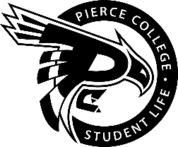
Pierce College Fort Steilacoom
General Assembly Agenda

Location: Student Life Lobby

Date: Friday, March 1 2019

Time: 2:00 p.m. – 3:00 p.m.

Agenda Details:
- Call to Order:
- Pledge of Allegiance:
- Roll Call:
- Establishment of Quorum:
- Changes to the Agenda:
- Approval of Minutes:
- Approval of the minutes from the February 15, 2019 General Assembly.
- Reports:
- Old Business:
- New Business:
- Action Item 1819 – 035: To ratify the Model United Nations Club for the 2018-2019 academic year.
- Action Item 1819 – 036: To ratify the Gaffer’s Club for the 2018-2019 academic year.
- Action Item 1819 – 037: To approve funding not to exceed $2500 for Phi Theta Kappa to send a member and an advisor to the 2019 National Conference in Orlando, Florida.

- Open Forum:

- Announcements:
- MS Awareness “Seeing Orange” is March 6 from 11-2 p.m. in the Fireside Lounge.
- ELA Workshop is March 8th from 12 – 1 P.M. in CAS 529
- Clubs Council Meeting is March 12th from 11-2 P.M. in OLY 205
- Adjournment:

