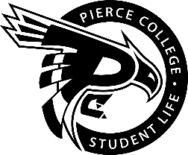
Pierce College Fort Steilacoom
General Assembly Agenda

Location: Student Life Lobby

Date: Friday, March 15, 2019

Time: 2:00 p.m. – 3:00 p.m.

Agenda Details:
- Call to Order:
- Pledge of Allegiance:
- Roll Call:
- Establishment of Quorum:
- Changes to the Agenda:
- Approval of Minutes:
- Approval of the minutes from the March 01, 2019 General Assembly.
- Reports:
- President Power
- Vice President Bromley
- Administrative Senator Fredericks
- Clubs and Organizations Senator Walker
- Legislative Senator Brigge
- Culture and Affairs Senator Cho
- Engagement Senator Pecache
- Activities Board Reports
- Old Business:
- No old business to review at this time.

- New Business:
- No new business to review at this time.
- Open Forum:
- Announcements:
- Raider Review is March 18 & 19th from 4 to 8 p.m. in the Performance and Fireside Lounge.
- Puppy Cuddle is March 19th from 11 – 2 P.M. in the Fireside Lounge
- Final Exams are Friday, March 22 & Monday and Tuesday, March 26-27^{th.}
See you Spring Quarter!
- Adjournment:

