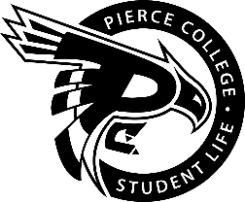
Pierce College Fort Steilacoom
General Assembly Agenda

Location: Student Life Lobby

Date: Friday, April 24, 2019

Time: 1:00 p.m. – 2:00 p.m.

Agenda Details:
- Call to Order:
- Pledge of Allegiance:
- Roll Call:
- Establishment of Quorum:
- Changes to the Agenda:
- Approval of Minutes:
- Approval of the minutes from the April 10, 2019 General Assembly.
- Reports:
- Old Business:
- New Business:
- Action Item 1819 – 040: To ratify the Role-play/Tabletop Club for the 2018-2019 academic year.

- Open Forum:
- Announcements:
- Emerging Leaders Academy is April 26 from 12-1 p.m. in CAS 529.
- Family Movie Night tickets available in the Student Life Office on April 29th
- Cascade Blood Drive is April 29 & 30 from 9 a.m. – 3 p.m. in the Outside Commons
- De-stress for Success is April 30th from 11 a.m. – 2:00 p.m. in the Fireside and Performance Lounge
- 2019-2020 ASPCFS Student Life Applications are due May 2 at 4:30 p.m.
- Civics week is May 6 from 3 p.m. – 4 p.m. in the Performance and Fireside Lounge & May 7th from 11 a.m. – 2 p.m. in the Student Life Lobby
- Clubs Council Meeting is May 7th from 12 -1 p.m. in OLY 202
- Next Student Government General Assembly is May 8th at 1 p.m. in the Fireside Lounge
- Adjournment:

