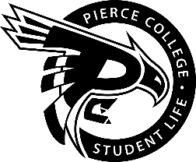
Pierce College Fort Steilacoom
General Assembly Agenda

Location: Student Life Lobby

Date: Wednesday, June 5th, 2019

Time: 1:00 p.m. – 2:00 p.m.

Agenda Details:
- Call to Order:
- Pledge of Allegiance:
- Roll Call:
- Establishment of Quorum:
- Changes to the Agenda:
- Approval of Minutes:
- Approval of the minutes from the May 22, 2019 General Assembly.
- Reports:
- Old Business:
- New Business:
- Action Item 1819-044: To ratify the Gaming and YEET Club for the remainder of the academic year.
- Action Item 1819-045: To approve $2000 in funding from the S&A Contingency budget to cover expenditures associated with athletics’ van repairs.
- Open Forum:
- Announcements:
- Nation Donut Day is June 7th and starts at 8 a.m. (while supplies last) in the Student Life Lobby.
- Summer Splash is June 10th from 11 a.m. – 2 p.m. on Cascade 4th Floor.
- Peace, Love & Ice Cream is June 11th from 12 – 1 p.m. in the Student Life Lobby.
- Student Awards Ceremony is June 12th at 6:30 p.m. in the Health Education Center.
- Chill N’ Grill is June 13th from 11:30 – 3 p.m. in the Performance & Fireside Lounge.
- Self-Defense Workshop w/ Lakewood P.D is June 14th in the Performance Lounge.
- ELA Workshop is June 14th from 12 – 1 p.m. in CAS 529.

- Adjournment:

