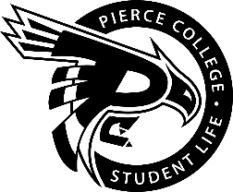
Pierce College Fort Steilacoom
General Assembly Agenda

Location: Student Life Lobby

Date: Wednesday, May 22, 2019

Time: 1:00 p.m. – 2:00 p.m.

Agenda Details:
- Call to Order:
- Pledge of Allegiance:
- Roll Call:
- Establishment of Quorum:
- Changes to the Agenda:
- Approval of Minutes:
- Approval of the minutes from the May 8, 2019 General Assembly.
- Reports:
- Old Business:
- New Business:
- Open Forum:
- Announcements:
- Karaoke Chaos is May 23rd from 11 a.m. – 2 p.m. in the Performance Lounge
- MLI Workshop is May 24th from 12 – 1 p.m. in CAS 529
- Clubs Bonanza is May 30 from 12. – 2 p.m. in the Performance & Fireside Lounge
- ELA Workshop is May 31st from 12 – 1 p.m. in CAS 529
- Clubs Council is June 4th from 12 – 1 p.m. in CAS 202
- Adjournment:

