Fire Service Leadership Management
Bachelor of Applied Science Degree
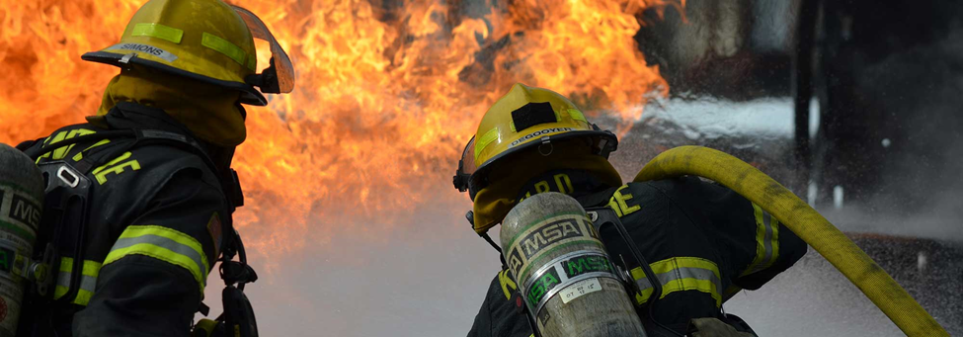

Application Packet

This is an application for admission to the Bachelor of Applied Science (BAS) in Fire Service Leadership Management. If you have questions or concerns, please contact us at any time.

Currently Accepting Applications

Contact: Joseph Dilley, DPA
Phone: 253-912-2336
Email: jdilley@pierce.ctc.edu

The Pierce College District does not discriminate on the basis of race, color, national origin, sex, sexual orientation, disability, or age in its programs and activities. Upon request, this publication will be made available in alternate formats.

Application Checklist

Admission to the BAS-FSLM program is competitive. Meeting minimum requirements does not guarantee admission, as the number of qualified applicants may exceed the number of available enrollment spaces.

Who is encouraged to apply:
- Applicants with an Associate degree in Fire Command Administration (FCA) or an Associate or Bachelor’s degree in any Fire Administration related field.

- Current or former members of the U. S. military seeking to build upon education, training and experience gained through military service in the Air Force, Army, Coast Guard, Navy or Marines or through service in the National Guard.

- Also encouraged to apply are individuals interested in and directly involved with any local fire department.

☐ Submit a completed application form for the Fire Service Leadership Management of Applied Science degree program. Note: Please make sure you have completed all elements of the application packet before sending to the FSLM program office.

☐ Official transcripts from a regionally accredited college must be submitted with the application packet (This includes transcripts from courses taken at Pierce College) mailed to:

Pierce College
Joseph Dilley
Fire Service Leadership Management – BAS
9401 Farwest Drive S. W., Lakewood, WA 98498-1999

- Note: If some/all transcripts are from other countries they will need to be evaluated. Evaluations can be conducted by any agency in NACES: http://naces.org/members.htm

☐ A personal statement (300-400 words). It is expected that this essay will be well written by the applicant. The statement will articulate the applicant’s personal and professional interests in a Bachelor of Applied Science in Fire Service Leadership Management (FSLM) degree and the profession of firefighting. The essay’s content, as well as spelling, grammar, and punctuation will be evaluated. The essay should describe the:

- Applicant’s background outlining work experience, military service, or volunteer experience.
- Personal and professional goals and how this degree relates to those goals.
- Work experience or specific attributes that you bring to the program and believe you can bring to the profession.
- Any other special considerations you believe will make you a good candidate.

☐ Submit one (1) Letter from a Personal, Professional or Academic reference.

☐ Submit your personal resume.

☐ Submit a letter from the fire department you are affiliated with proving affiliation.

Background Considerations: Prospective students should be aware that certain criminal behavior and criminal records may prohibit employment opportunities in the fire service. Prospective students are encouraged to research these situations and if they have any questions, then consult with the FSLM program advisor.

BACHELOR OF APPLIED SCIENCE IN FIRE SERVICE LEADERSHIP MANAGEMENT
APPLICATION FORM
Important:
- Please type or print legibly with black or blue ink

The BAS-FSLM program is offered in an online format. It is a cohort model (all students taking the same courses each quarter) that averages approximately 15 credits per quarter for six quarters.

SECTION 1- PERSONAL INFORMATION
First Name | Middle Initial | Last Name
Address, including apartment number | City |  | State | Zip Code
Day Phone | Cell Phone |  | Evening Phone
Date of Birth (mm/dd/yyyy) | Gender
Email Address | Previous Names  - 2.
Pierce College Student Identification Number
(If a current Pierce College student)

SECTION 2- COLLEGE ENROLLMENT HISTORY, CERTIFICATIONS
Educational History:
List all colleges, universities, and vocational/technical schools attended. List any additional institutions on a separate sheet of paper and attach. Please attach official transcripts with your application.

College, vocational, or technical school attended | City and State | Major | Years attended (YY)  From: To: | Did you graduate/or will graduate?  ____ Yes, Year_____________  ____ No, Month/Year
List any additional colleges and vocational / technical schools on a separate document and attach with application.

SECTION 3- WORK or VOLUNTEER EXPERIENCE
Employer | Position | Dates of Employment
List any additional employers or volunteer experiences on a separate document and attach with application.

SECTION 4 – REFERRAL INFORMATION
Check all that apply
- How did you hear about the Bachelor of Applied Science in Fire Service Leadership Management at Pierce College?
☐Employer:_________________ ☐Family/Friend:________________ ☐Radio ☐College Schedule
☐Social Media ☐College Advisor ☐Professor:_______________ ☐Pierce College Website
☐Internet Search ☐Bus Advertisements ☐Billboard ☐Community Survey
☐Other:_________________

I certify to the best of my knowledge that all statements on this form are true.

Signature:______________________________________________________________ Date:________

All Application materials must be mailed to:

Pierce College
Joseph Dilley
Fire Service Leadership Management – BAS
9401 Farwest Drive S. W.
Lakewood, WA 98498-1999

Fire Service Leadership Management BAS
Application Scoring Rubric

This Application Scoring Rubric is for reference only so that applicants may understand how the application will be evaluated upon submission.

FIRE SERVICE LEADERSHIP MANAGEMENT BAS APPLICATIONS
Element | Score | Max Possible Points
Personal Statement |  | 50
Letter of Recommendation |  | 10
GPA* (2.0 minimum required) |  | 40 (GPA x 10, e.g. 4.0=40)
Total Points |  | 100
*College level cumulative GPA

