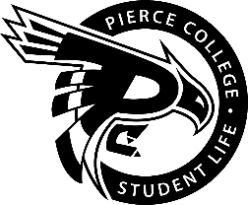
Pierce College Fort Steilacoom
General Assembly Agenda

Location: Student Life Lobby

Date: November 12, 2019

Time: 1:00 p.m. – 2:00 p.m.

Agenda Details:
- Call to Order:
- Pledge of Allegiance:
- Roll Call:
- Establishment of Quorum:
- Changes to the Agenda:
- Approval of Minutes:
- Approval of the minutes from the October 29th General Assembly.
- Reports:
  - President’s Report
Chaz Serna
  - Vice President’s Report
Jessica Edmonds
  - Administrative Senator
Jaein Cho
  - Legislative senator
William Wasson
  - Clubs & Organizations Senator:
John Shead
- Engagement Senator:
Han Duong
- Student & Cultural Affairs Senator:
RAYA
- Activities Board:
Dennis Johnson
- Old Business:
  - Action Item 1920-021: To ratify Muslim Student Association (MSA) Club.
- New Business:
  - Action Item 1920-025: To ratify Music Appreciation Club.
- Open Forum:
- Announcements:
- Next Student Government General Meeting Oct. 26st from 1pm to 2pm
- Adjournment:

