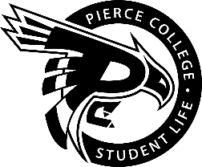
Pierce College Fort Steilacoom
General Assembly Agenda

Location: Student Life Lobby

Date: January 15, 2020

Time: 1:00 p.m. – 2:00 p.m

Agenda Details:
- Call to Order:
- Pledge of Allegiance:
- Roll Call:
- Establishment of Quorum:
- Changes to the Agenda:
- Approval of Minutes:
- Approval of the minutes from the December 3 General Assembly.
- Reports:
- President’s Report
Chaz Serna
- Vice President’s Report
Jessica Edmonds
- Administrative Senator
Jaein Cho
- Legislative senator
William Wasson
- Clubs & Organizations Senator:
John Shead
- Engagement Senator:
Han Duong
- Student & Cultural Affairs Senator:
RAYA
- Activities Board:
Dennis Johnson
- Old Business:
- New Business:
- Open Forum:
  - Baseball field proposal presentation by Duncan Stevenson
- Announcements:
- Next Student Government General Meeting is January 29 from 1pm to 2pm.

- Adjournment:

