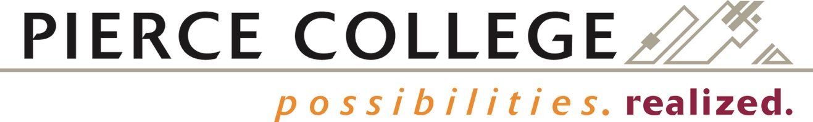

BOARD ACTION EXHIBIT NUMBER 2020-39
FINAL BOARD ACTION: April 15, 2020

Pierce College District

SABBATICAL LEAVE REQUEST FOR Hillary Stephens, Ph.D.
Physics and Astronomy Professor, Fort Steilacoom

NATURAL SCIENCES DIVISION

RESOLVED, that the Board of Trustees for Pierce College District, acting upon a recommendation from the Educational Leave Committee, the Vice Presidents of Learning and Student Success, and the Chancellor, hereby approves sabbatical leave for the 2020-2021 academic year for Hillary Stephens for the sole purpose of pursuing the professional development program set forth in her Sabbatical Memorandum of Understanding.

Professor Stephens will notify the Chancellor on or before 30 April 2020 that she will accept the sabbatical leave for the approved purpose and according to the terms provided in the signed Sabbatical Memorandum of Understanding. Further, that on or before 15 January 2021, Professor Stephens must notify the Vice President for Learning and Student Success at Pierce College Fort Steilacoom, in writing, whether she intends to return to Pierce College at the end of this leave, in accordance with the provisions of ARTICLE 6, SECTION 6.9 (Professional Leave/Sabbaticals) of the Faculty Agreement.

