REGULAR MEETING OF THE BOARD OF TRUSTEES
OF PIERCE COLLEGE

January 13, 2021
Zoom
1:00 p.m.
NOTE: Study Session 12:00
AGENDA
1. Call to Order/ Establishment of a Quorum.

2. Safety Announcement

3. General Matters.
A. Changes or Additions to the Agenda.
- Approval of Minutes for November 18, 2020 Meeting and December 9, 2020 Study Session

4. Public Comment

5. College Input and Reports
A. Associated Students of Pierce College Fort Steilacoom (ASPCFS) President.
Jasmeet Chahal
- Associated Students of Pierce College Puyallup (ASPCP) President.
Dillon Conner
- Pierce College Federation of Teachers (PCFT) President.
Curt Warmington
- Washington Public Employees Association (WPEA) Chief Job Steward
Cindy Bassage

6. Setting Direction/Vision
A. Chancellor Report
B. 2021 Budget Values and Principles

7. Board Action
A. Board Action 2021-01 Commitment of Reserves Puyallup Gaspard Student Services Remodel
B. Board Action 2021-02 Re-Adoption of Emergency Rule for the Student Code of Conduct

8. Institutional Effectiveness Monitoring Report
A. Workforce Education Graduate Survey Results TAB 1

9. Innovation and Student Success
A. Workforce Education Alumni Testimonials

10. Board Business
- Board Chair Report
- Activities Calendar

11. Executive Session.
Under RCW 42.30.110, an executive session may be held for the purpose of receiving and evaluating complaints against or reviewing the qualifications of an applicant for public employment or reviewing the performance of a public employee; consulting with legal counsel regarding agency enforcement actions or actual or potential agency litigation; considering the sale or acquisition of real estate; reviewing professional negotiations; and/or reviewing recommendations relative to the award or denial of tenure or renewal or non-renewal of faculty contracts.

Date of Next Meeting. February 10, 2021- Zoom

12. Adjournment

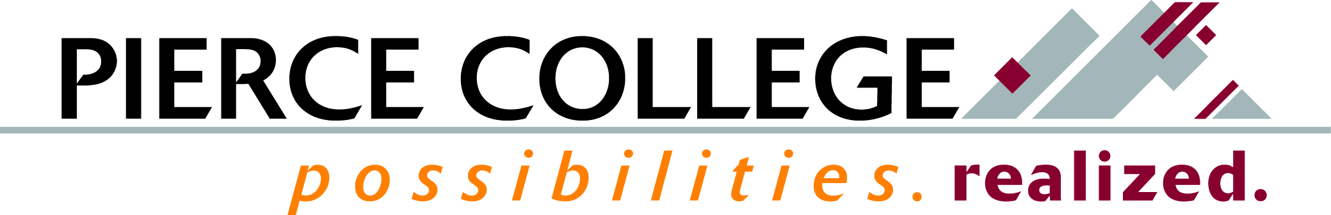

January 2021 Tab 1

Mission Fulfillment Monitoring Report
Workforce Education Graduate Survey (WEGS)

Brief Description
As a key part of our Mission, Pierce College provides workforce education programs for students seeking careers in professional and technical fields. In order to regularly evaluate and monitor the value of these programs, the Workforce Education Graduate Survey (WEGS) is administered each year during spring quarter. Post-graduation employment rates, job relevance, and wages, in addition to satisfaction with job preparation, are key indicators for how well the programs at Pierce prepared graduates to thrive in an evolving world.

How This Reflects Mission, Core Themes, or the Board’s Annual Goals
This reflects the Core Themes of Contribution to the Community and Student Learning and Success, specifically the Workforce Education and Professional/Technical Completers indicators, respectively.

Background Information and Analysis
The 2020 WEGS asks students nine months after graduating from workforce programs in the 2018-19 academic year about their employment status, earnings, and self-report and perceptual questions about program quality and relevance for their careers.
As a community college, Pierce seeks to contribute to its local community, meet the workforce training needs of that community, and to be a recognized leader in building and maintaining academic, industry and broad-based community partnerships to advance local educational and economic development.
Student learning and success represents a foundational measure of our Mission. The average reported employment rate going back to the 2010 survey is 74%. This year’s reported employment rate is at 81%. Two-thirds of employed respondents reported earning wages over $20 per hour, and nearly all respondents (96%) reported that they felt prepared for their current positions.

Potential Questions
1. Are there other tracking mechanisms besides WEGS?
- SBCTC DLOA and Dashboards
- ERDC Earnings for Graduates
2. How does the college currently act on workforce graduate data to improve programs?

Prepared by: Erik Gimness, Director for Institutional Research

