How to Create a New Account

If you are not a current user on [www.atitesting.com](http://www.atitesting.com/), you must create a new account to access the student portal or to make a purchase from ATI's online store. Follow the steps below to create a new account.

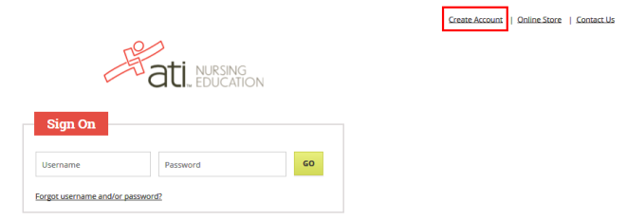

From the atitesting.com home page, click **Create Account**.

The Sign In Info page displays.

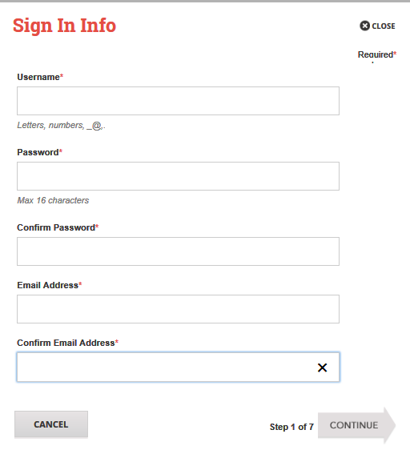

On the Sign In Info page, enter the account information that you will use to sign in to your account or to recover your account.

You must enter valid information into all the fields on this screen before you can proceed.

If your entry is not accepted, an error message similar to the one pictured below will display.



Reenter your information. When your entry is accepted, the message will disappear.

After you have entered all your account information, click **Continue** to go to the Security Questions page.

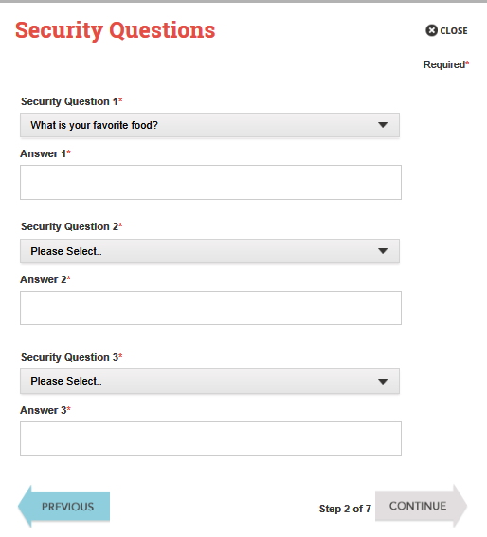

On the Security Questions page, select three different security questions, one from each list and enter your answer for each. Be sure to record your questions and answers for your future reference, in case you need to recover your account or you cannot remember your password.

Click **Continue** to enter your personal information.

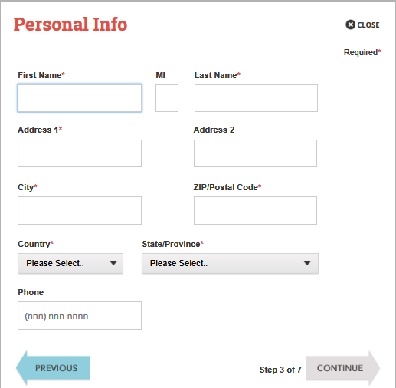

On the Personal Info page, enter your contact information. The following fields are required:

* First Name
* Last Name
* Address 1
* City
* ZIP/Postal Code
* Country
* State/Province

Click **Continue** to enter your Institution information.

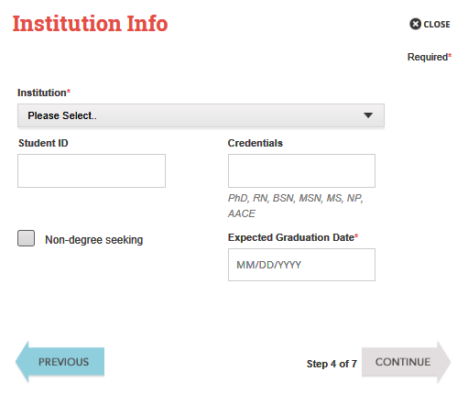

On the Institution Info page, select an Institution from the list and if you are seeking a degree, enter a date in *Expected Graduation Date*. All other fields are optional.

Click **Continue** to enter your Demographic Info.

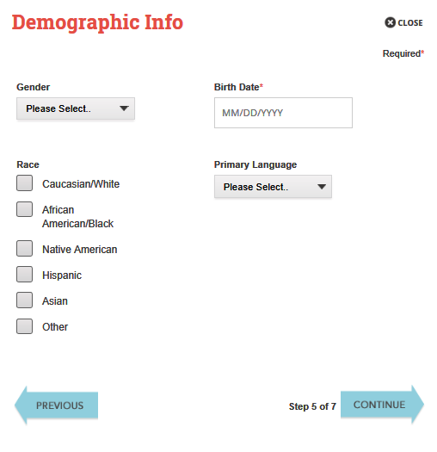

On the Demographic Info page, enter your *Gender*, *Birth Date*, *Race*, and *Primary Language* information. Only *Birth Date* is required.

Click **Continue** to go to Subscription, Updates & Notes.

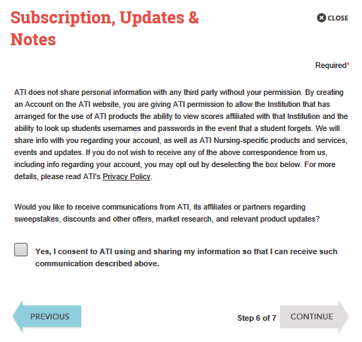

On the Subscription, Updates & Notes page, read the Subscription, Updates & Notes information.

If you agree to allow ATI to share your information under the terms presented on this screen, select the **Yes, I consent** check box.

Click **Continue** to go to User Terms and Conditions.

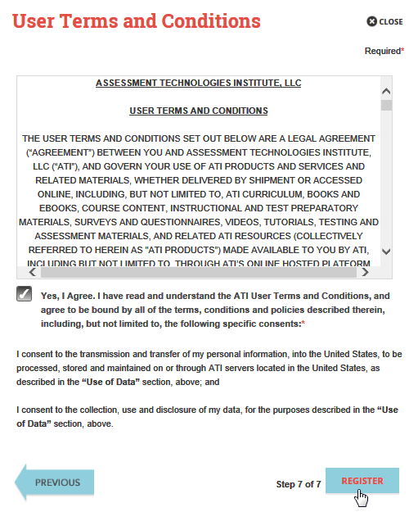

Click **Register** when you are finished creating your account.

Click **Previous** if you want to change any of the information you have entered for your new account.

On the User Terms and Conditions page, read the information under User Terms and Conditions.

Then select the **Yes, I Agree** check box to acknowledge that you have read the ATI User Terms and Conditions and agree to be bound by them.

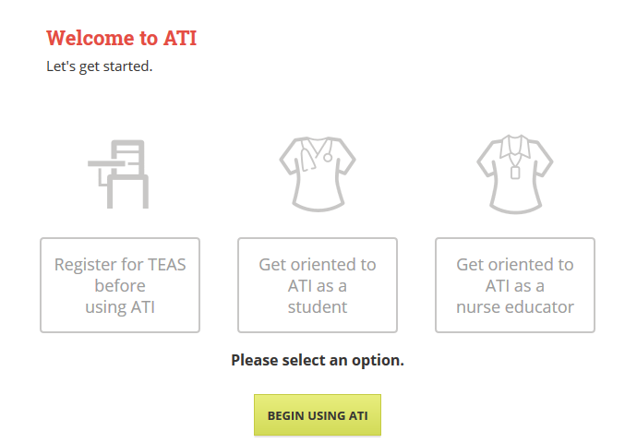

Click Begin Using ATI

Always be sure to Click Sign Out when you are ready to log out.



The next time you log into [www.atitesting.com](http://www.atitesting.com) you’ll be asked to select a site. Then Click the Log In button in the upper right-hand corner.

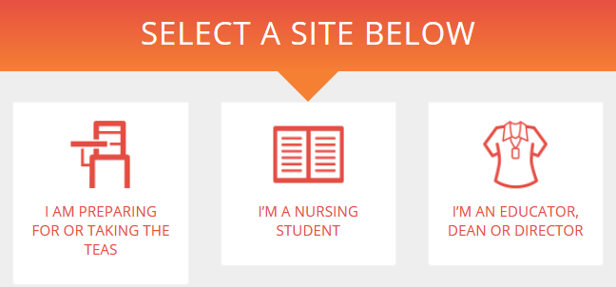



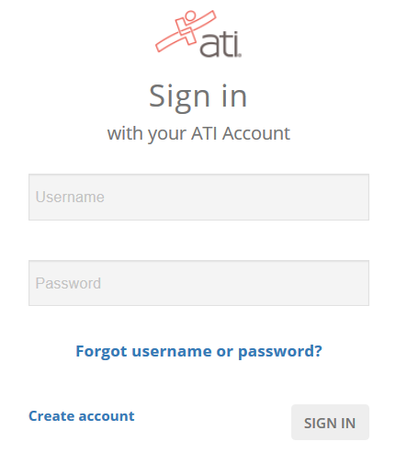

The Sign On window displays and your new Username is filled in for you. Enter your Password and click **GO** to launch the your Home page.