How to Pay for the TEAS Assessment at the Time of your Assessment
ATI has made it possible for students to pay for an individual TEAS Assessment online via the ATI Web site at the time of testing.
Complete the following steps to pay at the time of your assessment:
- STEP 1: Enter the Assessment ID
- STEP 2: Enter Payment Information
- STEP 3: Access the Assessment
Related Documents: How to Purchase a TEAS Transcript

STEP 1: Enter the Assessment ID
Sign in to www.atitesting.com with your Username and Password, or create a new account if needed.
On either the Student HOME page or MY ATI page, click Add Product in the upper right corner to open the Add Product window.
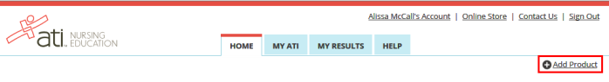

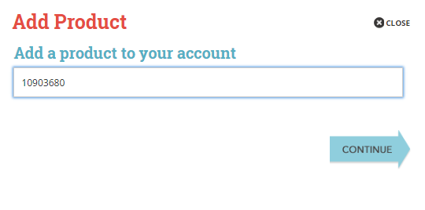
On the Add Product window, enter the Assessment ID number provided by your proctor and click CONTINUE.

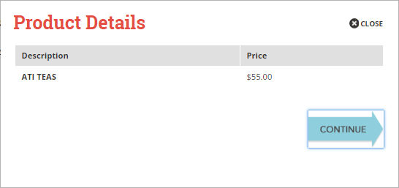
The Product Details window provides a description of your purchase, along with the price.
Click Continue.

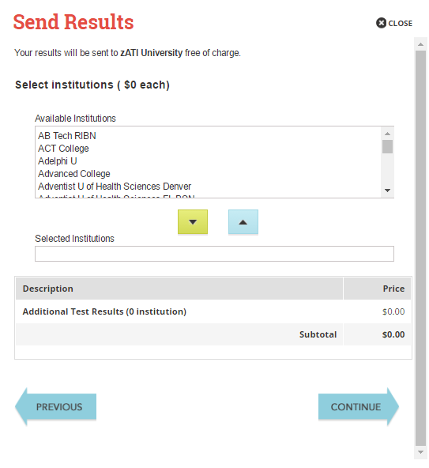
Since your institution will have a copy of your results, you may skip this section.
Click Continue.

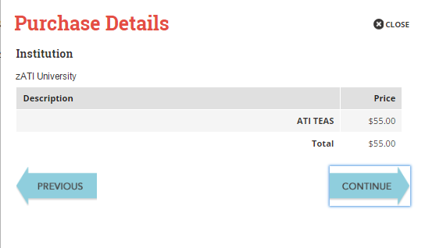
The Purchase Details window provides a summary of the name and price of the Proctored Assessment you are purchasing. Review this information to make sure it is correct.
When you are finished reviewing the information, click CONTINUE to pay.

STEP 2: Enter Payment Information
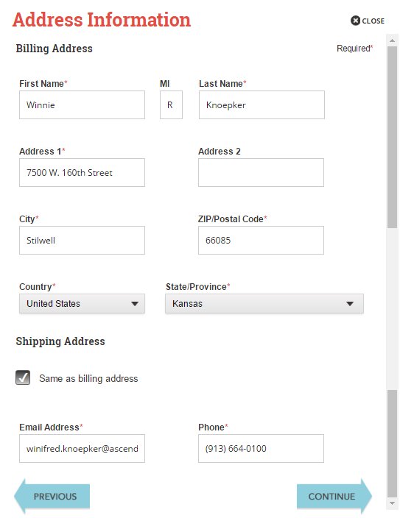
Verify that the address information from your account is correct and then click CONTINUE.
Make sure the Shipping Address box is checked. Since no product is being physically shipped, the Billing Address and Shipping Address are the same.

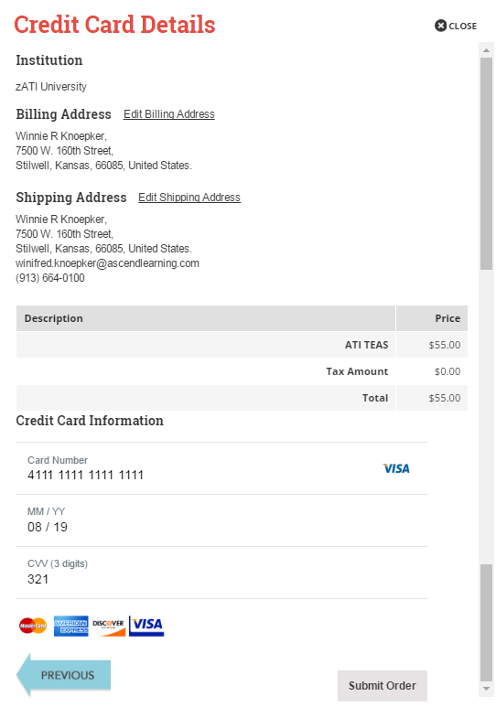
When you are sure all your information is correct, click Submit Order.
Enter your 16-digit Credit Card Number, your card’s Expiration Date. In the CVV Number field, enter the 3-digit security code from the back of your card.
Double-check your Billing Address information. If necessary, click Edit Billing Address to make any changes.
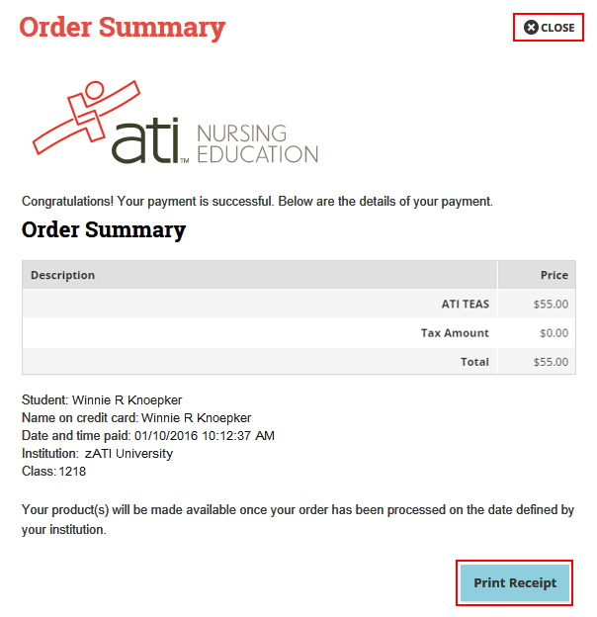
The Order Summary window confirms your payment and payment details.
To print a receipt, click Print Receipt, select your printer settings, if necessary, and then click Print.
Click CLOSE in the upper right corner to return to your student HOME page.

STEP 3: Access the Assessment
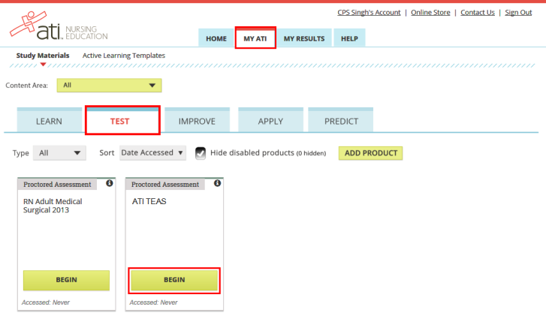
Click MY ATI and then TEST. The product card for the TEAS Assessment you purchased displays.
Click BEGIN to open the Instructions page and take the assessment.

Go back to the top

