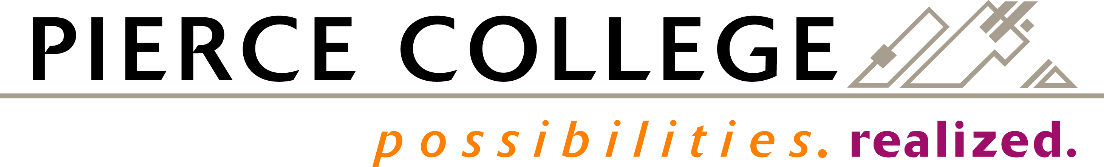

BOARD ACTION EXHIBIT NUMBER 2021-42
FINAL BOARD ACTION: May 12, 2021

Pierce College District

Adoption of Pierce College Student Code of Conduct
Washington Administrative Code (WAC) Final Rule

The Board of Trustees recognizes that Pierce College has undergone a revision process to maintain compliance with federal and state laws as well as to address best practices; and

WHEREAS, the proposed changes to the Student Code of Conduct WAC 132K-135-020 through 380 has been reviewed by Student Advancement Council, Learning Council, Equity Diversity and Inclusion Council, District Policy and Governance Cabinet, Assistant Attorney General, and the Board of Trustees, and presented for feedback in open public forums conducted virtually, and

WHEREAS, Pierce College is following the Washington Code Revisers Washington Administrative Code process to adopt changes to WAC 132K-135-020 through 380, and

WHEREAS, the District Policy and Governance Cabinet have reviewed and issued a statement of support for adoption of the Student Code of Conduct WAC 132k-135-20 through 380,

Therefore be it resolved, the Board of Trustees of Pierce College District Number Eleven hereby adopts the final rule for the Pierce College Student Code of Conduct (WAC 132K-135-20 through 380).

