REGULAR MEETING OF THE BOARD OF TRUSTEES
OF PIERCE COLLEGE

January 12, 2022
Pierce College Fort Steilacoom and Zoom
1:00 p.m.
NOTE: Study Session 12:00
AGENDA
1. Call to Order/ Establishment of a Quorum.

2. Safety Announcement

3. Flag Salute

4. General Matters.
A. Changes or Additions to the Agenda.
- Approval of Minutes for November
- Board Action 2022-01 Honoring Trustee Kristin Ray
- Board Action 2022-02Change of Officer

5. Public Comment

6. College Input and Reports
A. Associated Students of Pierce College Fort Steilacoom (ASPCFS) President.
Maham Khalid
- Associated Students of Pierce College Puyallup (ASPCP) President.
Vanessa Garcia
- Pierce College Federation of Teachers (PCFT) President.
Curt Warmington
- Washington Public Employees Association (WPEA) Chief Job Steward
Cindy Bassage

7. Setting Direction/Vision
A. Chancellor Report
B. Board Action 2022-03 Hiring a Search Consultant Firm
C. Board Action 2022-04 Chancellor/ CEO Search Advisory Committee

8. Institutional Assessment, Budget and Quality Assurance
A. District Budget Planning Values and Principles 2022

9. Institutional Effectiveness Monitoring Report
A. College Level English Success TAB 1

10. Innovation and Student Success
A. Anti-Racist Writing Ecologies

11. Board Business
A. Board Chair Report
- Activities Calendar

12. Executive Session.
Under RCW 42.30.110, an executive session may be held for the purpose of receiving and evaluating complaints against or reviewing the qualifications of an applicant for public employment or reviewing the performance of a public employee; consulting with legal counsel regarding agency enforcement actions or actual or potential agency litigation; considering the sale or acquisition of real estate; reviewing professional negotiations; and/or reviewing recommendations relative to the award or denial of tenure or renewal or non-renewal of faculty contracts.

Date of Next Meeting. February 2, 2022 Pierce College Puyallup

13. Adjournment

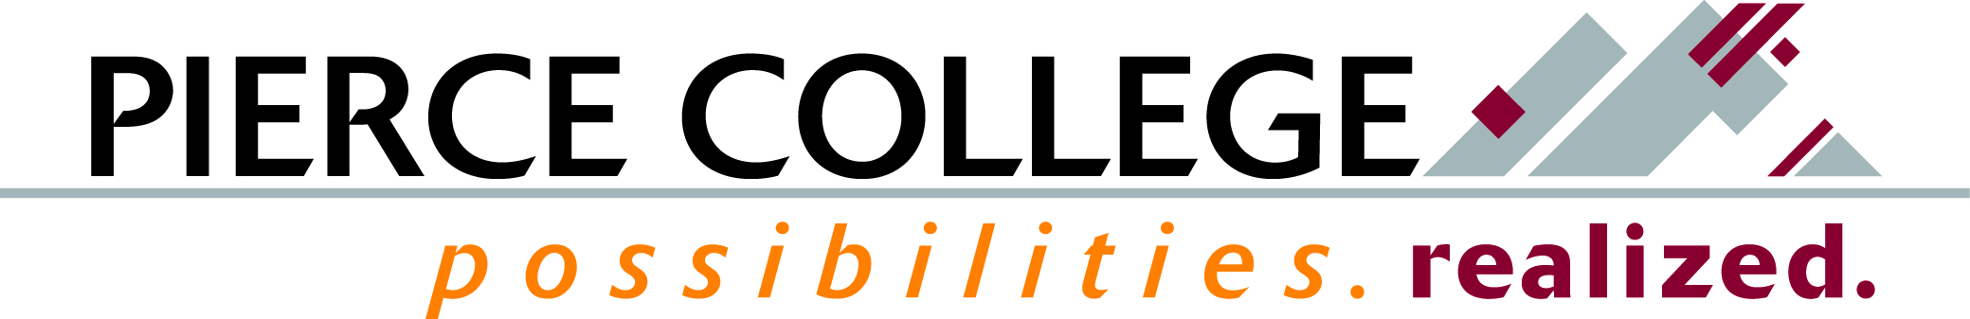

January 2022 Tab 1

Mission Fulfillment Monitoring Report
College-Level English Success

Brief Description
January’s Mission Monitoring, we’ll dive into college-level English successful course completion. One of the leading indicators for college retention and graduation is the rate at which students successfully complete college-level English within the first year of enrollment.

How This Reflects Mission, Core Themes or the Board’s Annual Goals
Course success data are related to our Core Theme of Student Learning and Success, specifically the Educational Momentum objective.

Background Information and Analysis
Pierce’s English department continues to innovate in ways to better serve our students, including co-requisite courses, improvements to guided self-placement, and innovative approaches to instruction—including the Antiracist Writing Ecologies that will be discussed in the Innovation Report.
One of the leading indicators for college retention and graduation is the rate at which students successfully complete college-level English within the first year. We will take examine these rates in addition to the disaggregated data.
Potential Questions
- How have college-level English participation and success changed over time?
- What has Pierce designed to ensure excellent student preparation in English while also supporting innovation, especially for males, HU students of color, and Black students?

Prepared by: Erik Gimness, Director for Institutional Research, Analytics, and Effectiveness

