Job & Career Connections Newsletter Spring Edition 2 – 2022

We are your Career Center, open to students, alumni, staff, faculty, and community for staff assisted and self-directed services. We are currently serving individuals remotely and in person at Fort Steilacoom and Puyallup. We continue to be available by email or phone. Contact information can be found in our Staff Directory on the last page.

Event & Workshop Features within Handshake!
Starting spring term, Pierce College District joined Handshake, an online platform that connects students and alumni with employers and recruiters in one location. One of the many resources within Handshake is the virtual face time events with employers. These events can range from quick 15 minute mini-sessions to full-day job fair events. Students can search for and sign up to attend Pierce College career events and employer-sponsored events.

Students can see a quick snap-shot of upcoming events from their main dashboard or view all upcoming events under the events tab. Employers and Pierce College Job & Career Connections continue to add events throughout the year, so it is a good idea to check often for updates and new events that may interest you.

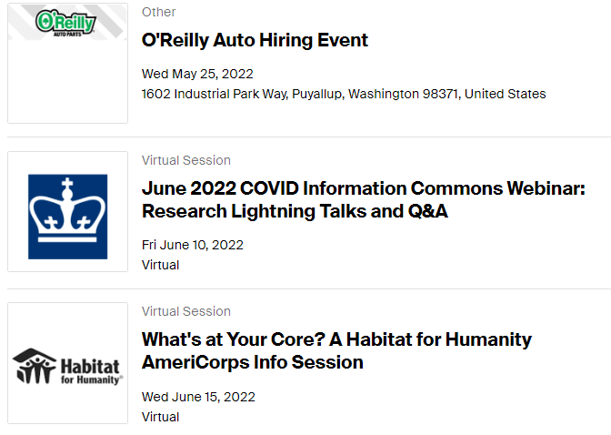

Not in Handshake yet? Claim your student account at https://pierce.joinhandshake.com to view these events and more!

Workforce Students Doing Amazing Things!
Congratulations to Heather Green and Amanda Davidson two of five Pierce College students selected for the 2022 All-Washington Academic Team as a recognition of their high academic achievement! The All-USA Academic Team honors students for their scholastic achievement and community and college service.

Read more about Heather and Amanda and the 2022 All-Washington Academic Team at:
Pierce College students selected for 2022 All-Washington Academic Team

Job & Career Connections (JCC) Mythbusters

Myth: Pierce College does not have a Career Center

Truth: Job & Career Connections (JCC) is Pierce College’s Career Center

Myth: Only current students can use Job & Career Connections (JCC)

Truth: JCC is open to any current student, alumni, staff, faculty, or prospective student

Myth: I need to be enrolled in a Workforce program to use Job & Career Connections (JCC)

Truth: JCC is open to all students, staff, faculty, and community from any program

Myth: Only Fort Steilacoom has Job and Career Connections (JCC)

Truth: Both Fort Steilacoom and Puyallup have Job and Career Connections (JCC). At Fort Steilacoom we are located in the Cascade Building on the 3rd floor across from the Welcome Center. At Puyallup we are in the Student Success Center.

Myth: I need an appointment to use Job & Career Connections (JCC)

Truth: JCC at both campuses have computers that can be used on a walk-in basis as available for self-directed use when the Welcome Center or Student Success Centers are open. Staff are available 8-11 for walk-ins or afternoon by appointment. If our afternoon appointment is open we do take last minute scheduling as available so don’t hesitate to call or stop in if you are on campus.

Myth: Job & Career Connections (JCC) and WorkSource are the same

Truth: JCC and WorkSource are different. JCC is your Pierce College Career Center. WorkSource is a statewide partnership of state, local and nonprofit agencies that provides an array of employment and training services to job seekers and employers in Washington.

Bottom Line: We are your Career Center, open to students, alumni, staff, faculty, and community for staff assisted and self-directed services.

Contact Diana Baker at 253-912-3641 or dbaker@pierce.ctc.edu OR Denise Green at 253-864-3385 or dgreen@pierce.ctc.edu with your Job Search and Career Exploration needs.

Funding Eligibility: www.startnextquarter.org
Jobs & Internships: https://pierce.joinhandshake.com
Pierce College Job & Career Connections Facebook: www.facebook.com/groups/1151589171538211/

Have a questions? Email us at JCC@pierce.ctc.edu
FS (Fort Steilacoom) Welcome Center, Cascade bldg. 3rd fl.
PY (Puyallup) Student Success Center, Gaspard Administration bldg., ADM 106
In-person and remote service available Monday – Friday from 8am to 11am for walk-ins or afternoon by appointment.

Workforce Staff Directory
Diana Baker, Job & Career Connections/Worker Retraining Manager dbaker@pierce.ctc.edu 253-912-3641
Adriana Tsapralis, BFET/WorkFirst Manager atsapralis@pierce.ctc.edu 253-912-2270
Annette Sawyer-Sisseck, Business/Accounting Navigator asawyer-sisseck@pierce.ctc.edu 253-864-3362
Denise Green, Workforce Coordinator dgreen@pierce.ctc.edu 253-864-3385
Eleni Palmisano, Metropolitan Development Council (MDC) Collocated Staff epalmisano@pierce.ctc.edu 253-722-3429
Mindy Mason, Workforce Coordinator mmason@pierce.ctc.edu 253-912-2399 ext. 5964
Roxanne Cassidy, Puyallup Opportunity Grant/HEET Coordinator rcassidy@pierce.ctc.edu 253-840-8329

