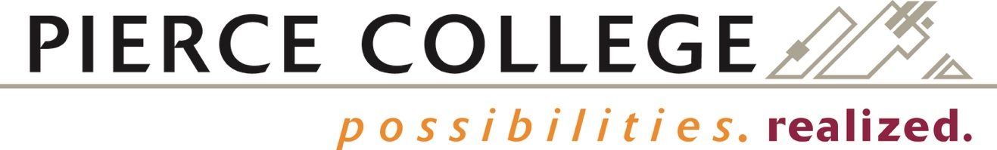

BOARD ACTION EXHIBIT NUMBER 2022-43
FINAL BOARD ACTION: May 11, 2022

Pierce College District

SABBATICAL LEAVE REQUEST FOR KRISTIN BRUNNEMER
ENGLISH PROFESSOR, FORT STEILACOOM

ARTS & HUMANITIES DIVISION

RESOLVED, that the Board of Trustees for Community College District Number 11, acting upon a recommendation from the Educational Leave Committee, hereby approves sabbatical leave for the 2022-2023 academic year for Kristin Brunnemer for the sole purpose of pursuing the professional development program set forth in her Sabbatical Memorandum of Understanding.

Professor Brunnemer will notify the Chancellor on or before 28 May 2022 that she will accept the sabbatical leave for the approved purpose and according to the terms provided in the signed Sabbatical Memorandum of Understanding. Further, that on or before 16 January 2023, Professor Brunnemer must notify the Vice President for Learning and Student Success at Pierce College Fort Steilacoom, in writing, whether she intends to return to Pierce College at the end of this leave, in accordance with the provisions of ARTICLE 6, SECTION 6.9 (Professional Leave/Sabbaticals) of the Faculty Agreement.

