Job & Career Connections Newsletter Summer Edition – 2022

We are your Career Center, open to students, alumni, staff, faculty, and community for staff assisted and self-directed services. We are currently serving individuals remotely and in person at Fort Steilacoom and Puyallup. We continue to be available by email or phone. Contact information can be found in our Staff Directory on the last page.

Career Events I Can & Should Attend Now!
Employers are constantly adding new events, workshops, virtual sessions, and hiring events through Handshake. These events enable students to explore possible career pathways and hear directly from industry experts about pathways, outlook, and personal experiences. Students can use these opportunities to build or grow their professional networks and these conversations may lead to deeper informational interviews, internships, job shadows, or possible employment.

When looking at the upcoming events, take a look at the event type and sponsored parties. Many offer additional information about their program, the employer, or other useful information. For example, an info session may look different from a hiring event. Many may leave space for breakout rooms to meet directly with employers and experts, while others may be more of a larger group format.

Employers continue to add events so it is recommended to check back often for newly added events. Click on the “Events” tab within your Handshake profile to view upcoming events. Flag events you want to save by clicking on the banner next to the event.

Sneak peak of some of the upcoming events:

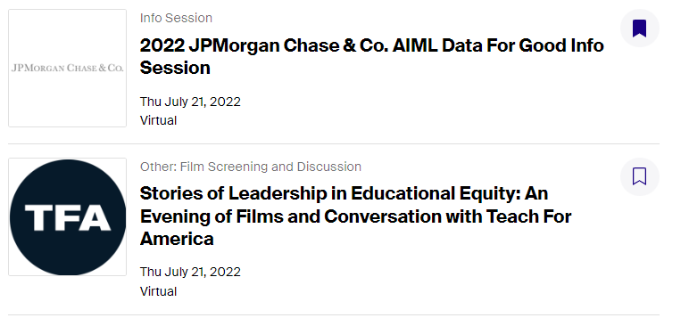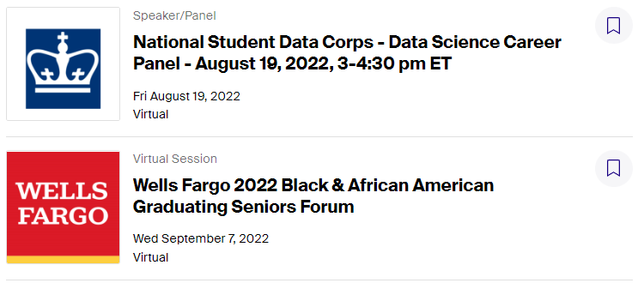

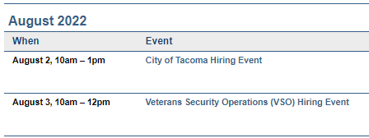
Hiring events and workshops with employers are also offered through your local WorkSource system. Go to www.worksourcewa.com to view future events and workshops and view all or sort by location, keyword, or type. A sneak peak of a few of their upcoming events:

Handshake on my phone?
Not only can you access Handshake from the Job & Career Connections page, but you can also download the Handshake App from the App Store or Google Play. Why? Using the App means you can search and apply to internships, work study, and part time jobs right from your phone and at your convenience. Students can be notified of messages from employers if enabled and get an early jump on viewing new job postings. The app also features Quick Apply to enable students to apply to jobs in two clicks.

Internships: What Are They & When Should I Start Looking For One?
An internship is one way a student can explore a career pathway, gain valuable hands-on experience, and often fulfill a program requirement. By definition, an internship should be paid and/or for credit. Most Professional Technical pathways include an internship component within their program map, however students in other programs may still choose to pursue an internship or other experiential learning experiences.

Internships could be considered an extension of the classroom where students can observe, participate in activities, and receive feedback from their site supervisor. When completed for credit, specific learning objectives, set number of hours, or other class-specific requirements may be necessary. In general, an internship is usually for one term, but may last longer. They may also be part-time or full-time and can vary between in person, hybrid, or remote work.

Planning ahead for an internship is critical. Much like finding a job, finding an internship that meets the needs of the program, the employer, and the student may take some time. It is recommended that students start preparing and searching for an internship one to two terms before the term they want to complete their internship. For example, a student who is interested in completing an internship during spring term may begin the process during the middle of fall term.

To apply for an internship, it is recommended that students have a current and professional resume, cover letter, and know the internship requirements (if any) for their pathway. Students may want to meet with their adviser to discuss the program requirements and if there are any existing relationships with employers.

Pierce College students can search and apply for internship online through Handshake using their Pierce College student credentials. While many companies may not be able to pay you or even have an internship posted, you may choose to contact them professionally to see if they would be open to an internship, volunteer, or job-shadow. In addition to Handshake, students may be able to explore internship options through other sites such as: www.linkedin.com, www.volunteermatch.org, or www.internships.com

For assistance with preparing for or searching for an internship, Job & Career Connections can help. Stop by during walk-in hours or make an appointment for help with internship search, creating or updating a resume and cover letter, preparing for an interview and more!

Funding Eligibility: www.startnextquarter.org
Jobs & Internships: https://pierce.joinhandshake.com
Pierce College Job & Career Connections Facebook: www.facebook.com/groups/1151589171538211/

Have a questions? Email us at JCC@pierce.ctc.edu
FS (Fort Steilacoom) Welcome Center, Cascade bldg. 3rd fl.
PY (Puyallup) Student Success Center, Gaspard Administration bldg., ADM 106
In-person and remote service available Monday – Friday from 8am to 11am for walk-ins or afternoon by appointment.

Workforce Staff Directory
Diana Baker, Job & Career Connections/Worker Retraining Manager dbaker@pierce.ctc.edu 253-912-3641
Adriana Tsapralis, BFET/WorkFirst Manager atsapralis@pierce.ctc.edu 253-912-2270
Annette Sawyer-Sisseck, Business/Accounting Navigator asawyer-sisseck@pierce.ctc.edu 253-864-3362
Denise Green, Workforce Coordinator dgreen@pierce.ctc.edu 253-864-3385
Eleni Palmisano, Metropolitan Development Council (MDC) Collocated Staff epalmisano@pierce.ctc.edu 253-722-3429
Mindy Mason, Workforce Coordinator mmason@pierce.ctc.edu 253-912-2399 ext. 5964
Roxanne Cassidy, Puyallup Opportunity Grant/HEET Coordinator rcassidy@pierce.ctc.edu 253-840-8329

