COMMUNITY COLLEGE DISTRICT NO. 11 PIERCE COLLEGE

April 10, 2024
MINUTES OF THE REGULAR MEETING

BOARD MEMBERS PRESENT

Lisa Boyd

Clemencia Castro Woolery

Therese Pasquier
Brett Willis

COLLEGE OFFICERS PRESENT
Dr. Julie White, Chancellor and CEO
Dr. Matthew Campbell, President Fort Steilacoom
Dr. Ilder Betancourt Lopez, VP for Learning and Student Success
Ms. JoAnn Baria, VP for Workforce, Economic, and Professional Dev.
Mr. Andrew Glass, VP for Technology and Infrastructure
Ms. Deena Forsythe, Interim Vice President for Human Resources
Ms. Ha Nguyen, VP for Equity, Engagement, and Belonging
Mr. Curt Warmington, President PCFT

OTHERS PRESENT
See list

STUDY SESSION
No study session this month.

CALL TO ORDER
Ms. Pasquier called the meeting to order at 1:00 pm.

SAFETY MESSAGE
Ms. Pasquier read the safety message

PLEDGE OF ALLEGIANCE
Ms. Pasquier led the group in the pledge.

QUORUM
A quorum was established with all members present.

CHANGES/ADDITIONS
None

MEETING MINUTES
Mr. Willis moved and Ms. Boyd seconded the motion to approve the minutes of the March 20, 2024 meeting minutes. MOTION PASSED

PUBLIC COMMENT
None

COLLEGE INPUT AND REPORTS

Associated Students of Pierce College District (Reported by Sam Pena Rojas)
Mr. Pena Rojas and others reported on the activities in Student Government and Student Activities.
Both campuses held Welcome days, with students enjoying meals, swag items, handbooks, while being welcomed back by student leaders and their peers.

Student Government teams have been working on reviewing and voting on 60 S&A and Tech Fee packets. They have been planning many events including Earth Day activities, club fair, and a Japanese celebration event.

Pierce College Federation of Teachers PCFT (Reported by Curt Warmington)
Mr. Warmington noted that bargaining continues, he had projected that bargaining would have ended by now, it hasn’t, to a great extent because he brought up a couple of issues from our list we haven’t dealt with. They are meeting Monday for a long session where we hope will be able to conclude our 2 years of bargaining, and vote for ratification soon after.
Mr. Warmington reported that many faculty continue to be concerned about safety and security, so the PCFT is creating a letter of concern about that topic. These concerns grow out of many issues, including last quarter’s campus evacuations, the systems breech last summer, among others. We have raised concerns with the administration, but the PCFT feels that a formal declaration is appropriate.
He noted that AFT Powerful Locals Engagement Grant, the grant helps fund our engagement program with faculty. Last February we hosted a guest speaker on open negotiations. Last week we focused on the leveling process for adjunct faculty and talked about the process and how to be successful, led by 2 of our adjunct faculty PCFT leaders.
SETTING DIRECTION AND VISION

Chancellor’s Report

Dr. White stated that April is Community College Awareness Month, and this feels like a good time to share my favorite quote about community colleges. Before she read the quote, she explained about its author, Kay Ryan. Ryan is an alumna of Antelope Valley College (a community college) and went on to receive bachelor’s and master’s degrees in English from UCLA. She taught part-time at the College of Marin (also a community college). She was the US Poet Laureate from 2008-2010, and was the first openly lesbian U.S. Poet Laureate. She won the Pulitzer Prize for Poetry in 2011 and received the MacArthur fellowship in 2011. With that background, here is her quote:
“I simply want to celebrate the fact that right near your home, year in and year out, a community college is quietly — and with very little financial encouragement — saving lives and minds. I can’t think of a more efficient, hopeful or egalitarian machine, expect perhaps the bicycle.”
With that affirmation of the important work we do, Dr. White has organized her report a little differently today, to connect it directly to the strategic goals we have outlined together. In the area of financial stewardship, we are in the midst of our budget planning process, and you’ll hear more about that when we review the action item on fees. In terms of capital projects, we have an update on the Olympic South renovation project, and Dr. Campbell will provide an update on that.

Dr. Matt Campbell:
If you have been keeping tabs on the abatement and renovation of the Olympic South Building, things are really starting to ramp up. As mentioned recently, we have moved through the permitting phase and work is becoming more visible. The building is no longer wrapped in plastic and progress on the external panels and glazing can now be seen, especially on the west side.
And we’ve finalized some of the internal design aspects down to furniture and fabrics.
We had been hoping for a Winter 25 start, though that is almost certainly a Winter move-in with classes starting Spring 25. Finally, the selected artist, Dionne Bonner of Tacoma is ramping up development of the work that will be part of the project. A huge element in her selection and process is community involvement. She hosted a college community input session yesterday and will be hosting a workshop session on the 18th from 10am-2pm on the 4th floor of Cascade.

Dr. White noted that in the area of strengthening external partnerships, it has been a very busy few weeks! Pierce College sponsored a table at the annual gala of the Native Action Network, an organization promoting Native women’s leadership. Chio and I attended, and we continue to make progress in building relationships with tribal communities. She met with a leader from Tacoma Public Utilities to talk about workforce development needs in green energy and how the college can work to address those needs.

Dr. White serves on the Blue Zones Parkland Spanaway Steering Committee, where she learned that Pacific Lutheran University will be building a new health education and care center, to address health care inequities in the Parkland/Spanaway area. We’ll be talking with them more about future partnership opportunities, such as clinical and other opportunities for our students.
In 2022, the state legislature provided funds for us to work with community organizations in providing financial aid access and support to underserved communities. We are collaborating with Clover Park Technical College, Tacoma Community College, and Bates Technical College in this program. We have contracted with Metropolitan Development Council and the Foundation for Tacoma Students, focusing on adults over the age of 25. They have worked with over 1,300 adult learners for financial aid support and are developing a mobile hub to expand their outreach.
Dr. White has met with several community leaders to discuss opportunities for service on the Board of Trustees, and is hopeful that we will have an application to the Board filed shortly, with others in the pipeline.

At the national level, she is continuing her service on the American College Health Foundation Board, representing the community college sector in advancing the health, wellbeing, and overall success of our students. She just returned from the American Association of Community Colleges annual meeting, where she spoke on a panel organized by Amazon about generative AI and higher education. She also met with representatives from Amazon to discuss partnership opportunities for workforce development.

In the area of employee recruitment, retention, and professional development, Dr. White started by responding to Curt’s earlier comments regarding safety and security. She and Curt met a couple of months ago regarding concerns from faculty. She responded to those concerns and am not aware of any additional concerns. She looks forward to continuing to collaborate with faculty to address any remaining issues.

We have responded to the results of our telework survey, which indicated that many employees, especially those who do not telework, experience challenges with communication and connections with their colleagues. In order to strengthen connections and provide equitable access to resources for our students, we have designated Tuesdays as an in-person day. We are holding community-wide events most Tuesdays in order to support this goal.

Dr. White was excited to report that we have hired a Vice President for Learning and Student Success at Pierce College Puyallup, Ms. Yuritzi Lozano. Yuritzi is joining us from Wenatchee Valley College, where she served as Dean of Allied Health and Professional Technical Programs. Prior to this role, she gained student services experience as the College Assistance Migrant Program Director at WVC and as Program Manager for Highline College’s Trio Student Support Services Program. She is currently pursuing a doctorate in adult and higher education with a focus in community college leadership from Oregon State University. Yuritzi will join us May 16.

Dr. White recognized Dr. Ilder Betancourt Lopez, who was hired to serve as the Vice President of Learning and Student Success at Pierce College Fort Steilacoom. As we all know, he has done that and more, having filled gaps due to vacancies in the Puyallup counterpart position and in Institutional Research, and anywhere else he could, all while leading innovations like our revised faculty hiring, onboarding, and tenure process. Ilder, I can’t thank you enough. You are critical to Pierce College’s success. Your passion for equity drives your work, and has helped her, and all those you work with, become better in serving our students and communities. Thank you.
Finally, Pierce College is being recognized for its equity work by the Washington Association of College Trustees, who will honor us with the 2024 Equity Award at their Spring Conference’s Awards Dinner on May 2.
BOARD ACTION

Board Action 2024-26 Fee Schedule 2024-2025
Ms. Castro-Woolery moved and Mr. Willis seconded the motion to approve. MOTION PASSED
Mr. Glass reviewed the fee schedule noting the increases and decreases for the 2024-25 fees.

Board Action 2024-27 Full Sabbatical Leave for Davida Sharpe-Haygood
Ms. Boyd moved and Mr. Willis seconded the motion to approve as presented. MOTION PASSED
RESOLVED, that the Board of Trustees for Community College acting upon a recommendation from the Educational Leave Committee, hereby approves sabbatical leave for the 2024-2025 academic year for Davida Sharpe-Haygood for the sole purpose of pursuing the professional development program set forth in her Sabbatical Memorandum of Understanding.

Professor Sharpe-Haygood will notify the Chancellor on or before 28 May 2024 that she will accept the sabbatical leave for the approved purpose and according to the terms provided in the signed Sabbatical Memorandum of Understanding. Further, that on or before 16 January 2025, Professor Sharpe-Haygood must notify the Vice President for Learning and Student Success at Pierce College Fort Steilacoom, in writing, whether she intends to return to Pierce College at the end of this leave, in accordance with the provisions of ARTICLE 6, SECTION 6.9 (Professional Leave/Sabbaticals) of the Faculty Agreement.

Board Action 2024-28 Two Quarter Sabbatical Leave for Monica Nucciarone
Ms. Castro-Woolery moved and Ms. Boyd seconded the motion to approve as presented.
MOTION PASSED
RESOLVED, that the Board of Trustees for Community College acting upon a recommendation from the Educational Leave Committee, hereby approves sabbatical leave for two quarters during the 2024-2025 academic year for Monica Nucciarone for the sole purpose of pursuing the professional development program set forth in her Sabbatical Memorandum of Understanding.

Professor Nucciarone will notify the Chancellor on or before 28 May 2024 that she will accept the sabbatical leave for the approved purpose and according to the terms provided in the signed Sabbatical Memorandum of Understanding.

Dr. Betancourt Lopez provided an overview of each of the projects the faculty will engage in during their sabbatical.
Institutional Effectiveness Monitoring-Advancing Equity from Access to Completion
Dr. Sieving examined enrollment data, credit completion for first-year, and graduation and transfer out rates with a focus on race and ethnicity with the understanding that our students have many identities and inclusion spans across all identities. From an access perspective we see higher representation of Black and African American and Hispanic and Latino students than Pierce County overall. Marked increase in the number of students completing credit milestones in year 1. Equity gaps remain for our Historically Underserved (HU) Students of Color in achieving credit milestones. Gradual increase in degree and certification completion. Yet we are 10% below our 2027 Institutional Goal, with our HU Students of Color the most impacted.

Innovation Report- Inclusive Practices: from “IT “to “I”, Steps to Operationalizing IP
Ms. Lui Yang, Director of Inclusive Practices provided a presentation on Inclusive Practices. She noted that: Access without support is not opportunity. Leave space for non-instructional staff to interpret inclusive practices and make their own connections and alignments. We are striving to see oneself in the work and inclusive practices as a solution.
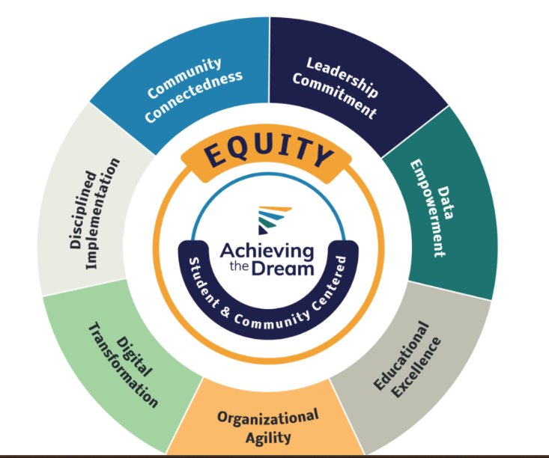
BOARD BUSINESS

Board Chair Report
Ms. Pasquier expressed her appreciation and pride in the DEI work that the college engages in, a well-deserved award from ACT. Ms. Boyd noted that she attended several events this month building community in Lakewood and serving as an advocate for the college.

ACTIVITIES CALENDAR
The activities calendar was discussed, and members will let the Board secretary know which events they can attend.

NEXT REGULAR MEETING May 8, 2024, Fort Steilacoom Campus

ADJOURNMENT The meeting adjourned at 2:17 pm.

________________________ _______________________
Julie A. White, Chancellor Therese Pasquier, Chair
Community College District No. 11 Community College District No. 11
Pierce College Pierce College
Attendance
yes
Therese Pasquier
Clemencia Castro Woolery
Lisa Boyd
Brett Willis
Chris Boiter
Elizabeth McAmis
Julie White
Ilder Betancourt Lopez
Matt Campbell
JoAnn Baria
Andrew Glass
Curt Warmington
Eddy Perry
Ron May
Lori Griffin
Kelly Benson
Allison Sieving
Holly Smith
Christie Flynn
Anne White
Krissy Kim
Dawn Reed
James Lett
Deena Forsythe
Shawna Freeman Lane
Cheryl Batschi
Ha Nguyen

