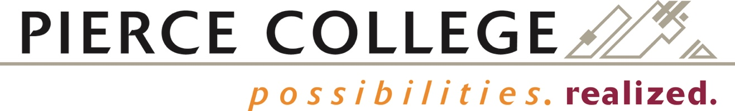

BOARD ACTION EXHIBIT NUMBER 2017-31
FINAL BOARD ACTION: April 12, 2017

Pierce College District Number Eleven

Associate in Music - Direct Transfer Agreement/Major Ready Pathway

WHEREAS the Direct Transfer Agreement (DTA) is designed to facilitate transfer from any State Board for Community and Technical College (SBCTC) to four-year colleges and universities in Washington state; and;

WHEREAS the DTA provides priority consideration in admissions to public institutions for many programs, completion of lower division general education requirements, credit for all courses completed within the DTA, and the opportunity to complete requisites for a future major; and;

WHEREAS the Major Ready Pathway (MPR) is designed to prepare students for entry into specific majors at receiving four-year colleges and universities in Washington state; and;

WHEREAS effective February 16, 2016, an agreement for this degree that meets all DTA requirements was established between the SBCTC and the 4-year institutions in Washington state; and;

WHEREAS the Pierce College music program enrolls many students with a goal of transferring and earning their bachelor’s degree in music or music education; and;

WHEREAS the Music program faculty and the Learning Council have approved all curriculum and degree requirements,

NOW, THEREFORE BE IT RESOLVED that the Board of Trustees of Community College District 11, Pierce College hereby approves the addition of an Associate in Music – DTA/MRP and authorizes the college to begin awarding the degree beginning with the 2017-18 academic year.

