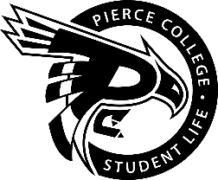
Pierce College Fort Steilacoom
General Assembly Agenda

Location: Zoom

Date: May 18, 2020

Time: 2:00 p.m. – 3:00 p.m.

Agenda Details:
- Call to Order:
- Pledge of Allegiance:
- Roll Call:
- Establishment of Quorum:
- Changes to the Agenda:
- Approval of Minutes:
- Approval of the minutes from the May 4, 2020 General Assembly.
- Reports:
- President’s Report
Jessica Edmonds
- Vice President’s Report
Jaein Cho
- Administrative Senator
Jas Chahal
- Clubs & Organizations Senator:
William Wasson
- Engagement Senator:
Han Duong
- Student & Cultural Affairs Senator:
RAYA
- Legislative Senator:

- Activities Board:

- Old Business:
- New Business:
- Action Item 1920-058: To ratify Anji Amgalanbaatar as a member of the Selection Committee.
- Action Item 1920-059: To ratify Ashley Chambers as a member of the Selection Committee.
- Open Forum:
- Announcements:
- The next SG General Assembly is on June 1, 2020.

- Adjournment:

